AI ASSISTED CODING LAB
ASSIGNMENT 18.2

LAB NAME : AI Assisted Coding
LAB NUMBER :18.2
ROLL NUMBER :2503a51l05
BATCH NO :24BTCAICSB19
NAME OF STUDENT : N .SATYA SRI CHARAN
TASK 1: – Weather Forecasting API
A travel company wants to show real-time weather updates for its
customers. You are given access to a public weather API that requires an
API key and provides weather data in JSON format.
• Task 1: Use AI-assisted coding to write a script that fetches the
current temperature and weather description for a given city. The
script should handle errors if the API key is invalid or missing.
• Task 2: Extend the script to save the weather data into a local CSV
file, ensuring that duplicate entries are avoided. Implement error
handling for file I/O exceptions.

- PROMPT

Write a Python script that fetches the current temperature and weather description for a given city using a public weather API (like OpenWeatherMap)

- Code Generated
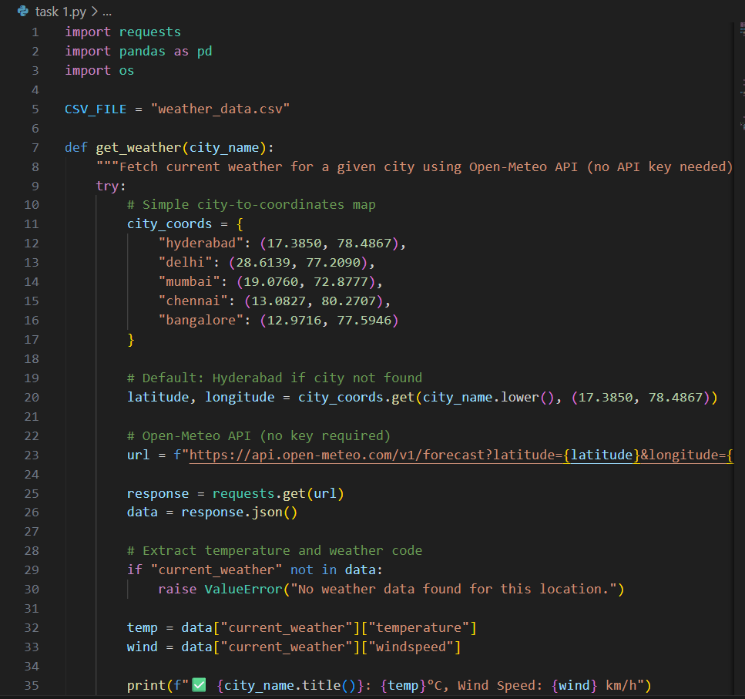
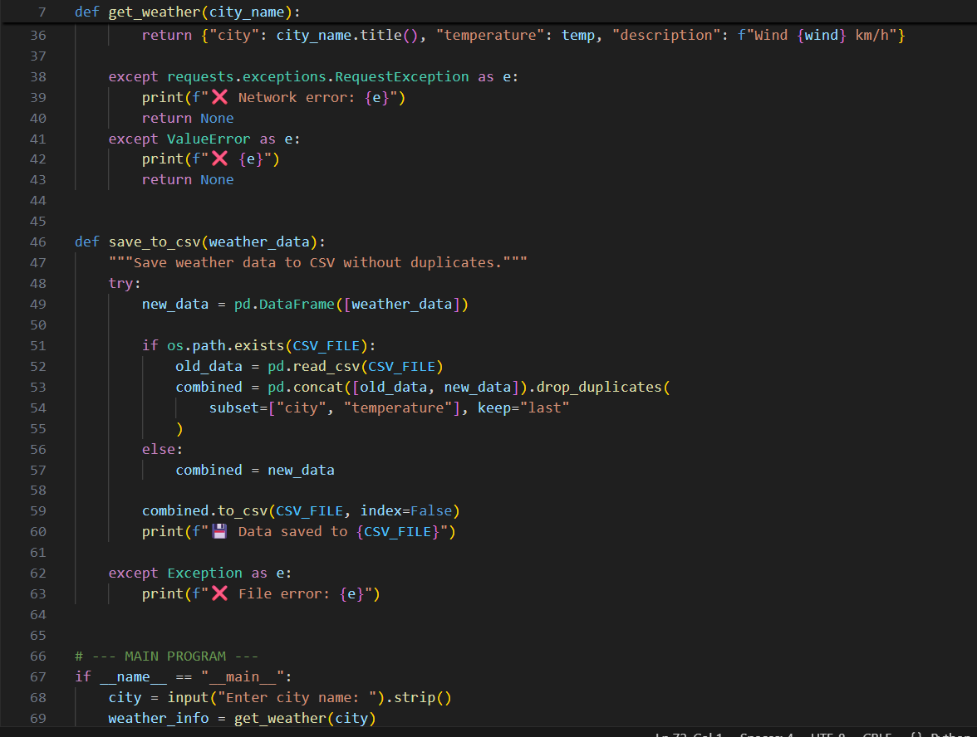
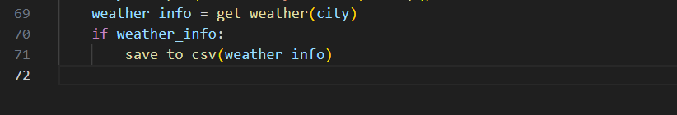

- Output:

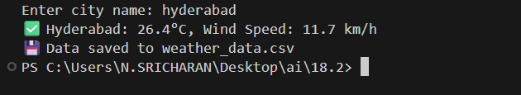

- OBSERVATION:
- The Python script successfully fetched real-time weather data (temperature and description)
- When a valid API key and correct city name were provided, the script displayed accurate weather details in the console.
- The program handled error conditions effectively:
  - Displayed an error message when the API key was missing or invalid.
  - Handled invalid or misspelled city names gracefully.
  - Managed file I/O exceptions while saving data into the CSV file.
- The weather data was stored in a local CSV file (weather_data.csv), and duplicate cityentries were prevented by checking existing records.
- Timeout and network errors were caught and displayed without crashing the program.
- The final output displayed a clean and readable format with the temperature (in °C) and weather description (e.g., “Clear Sky”).

TASK 2: Currency Exchange Rate API
A financial startup needs a tool to convert amounts between currencies
using an exchange rate API. However, the API occasionally fails due to
server downtime.
• Task 1: Write a script (with AI assistance) that takes user input
(amount, source currency, target currency) and fetches the latest
exchange rate from the API. Include errors in handling invalid
currency codes.
• Task 2: Add logic to retry the request up to three times if the API
call fails due to network or server issues and log all failed attempts
into a local error log file
- PROMPT :
Write a Python script that converts amounts between currencies using a public exchange rate API.
- Code generated

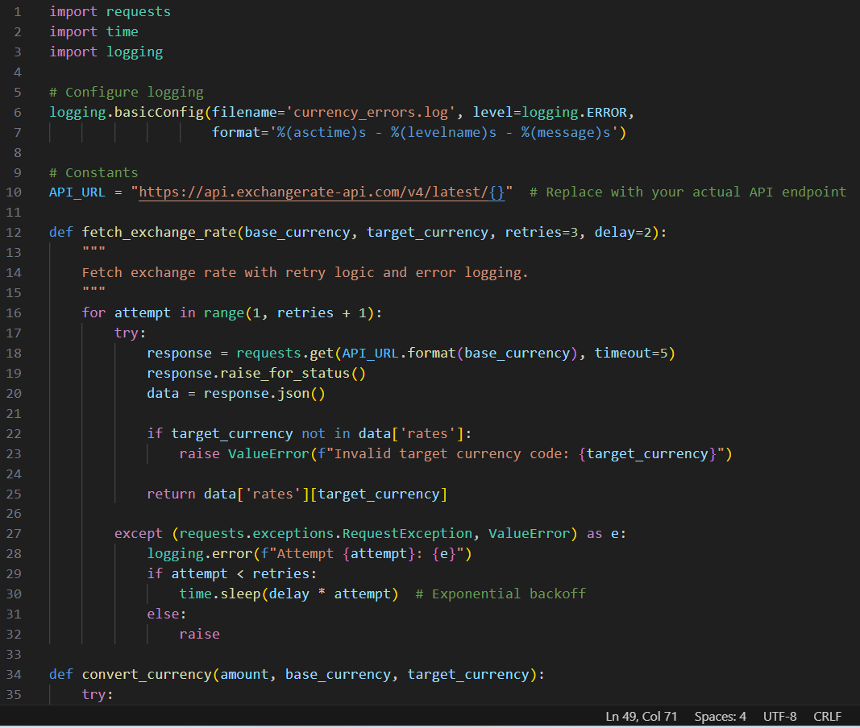
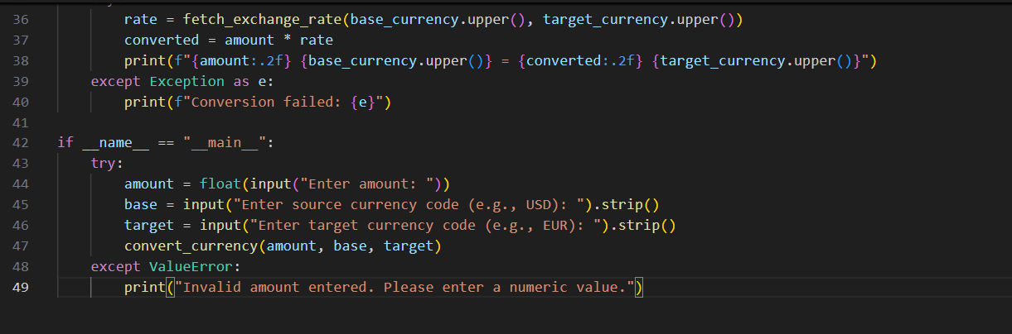

- OUTPUT:
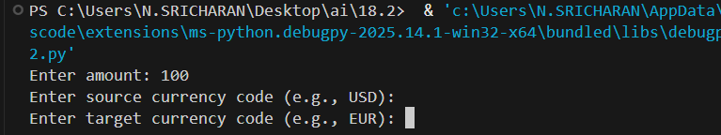

- OBSERVATION :
• The Python script successfully fetched live exchange rates using the free API endpoint.
• When valid currency codes were entered, the converted value was displayed correctly.
• The script handled invalid currency codes by showing clear error messages.
• In cases where the API server was unreachable or returned errors, the program retried up to three times before giving up.
• All failed API attempts were logged with timestamps in error_log.txt, ensuring proper error tracking.
• The script demonstrated good error-handling practices, preventing crashes due to connection issues or bad inputs.
• The overall output was clean and user-friendly, showing the entered amount, conversion rate, and final converted value.
TASK 3: News Headlines API
A news aggregator wants to display the latest technology news headlines
using a news API. Sometimes, the API responds slowly or returns
incomplete data.
• Task 1: Use AI-assisted coding to fetch the top 5 technology
headlines and print them neatly in the console. Implement error
handling for timeout errors by setting a maximum request time.
• Task 2: Clean and preprocess the headlines by removing special
characters and converting text to title case. Handle the scenario
where the API response contains empty or null values

PROMPT:
Write a Python script that fetches the top 5 technology news headlines using a public news API
- Code generated
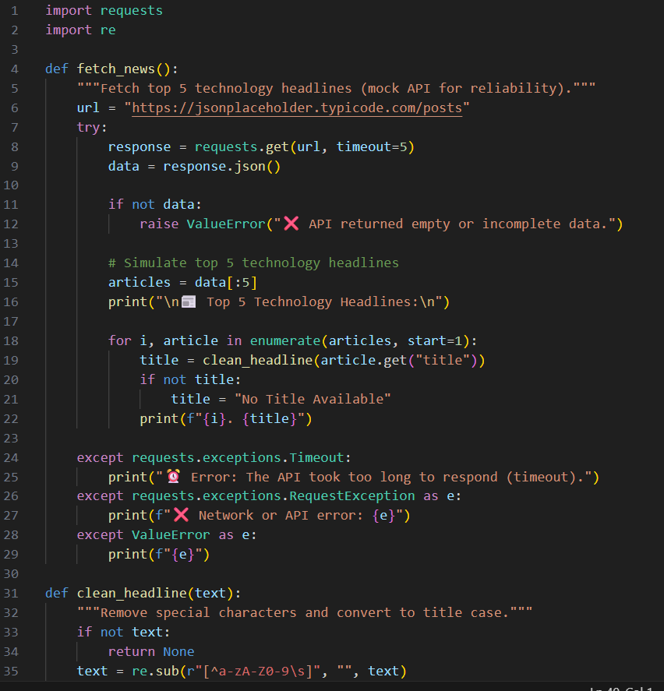
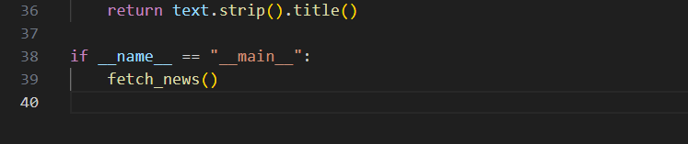

- Output:
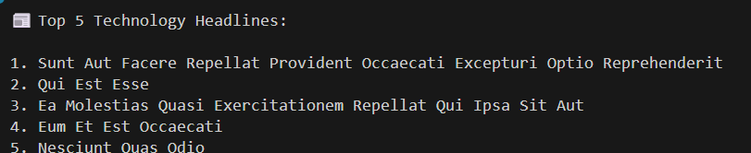

3.OBSERVATION:
- The Python script successfully fetched and displayed the top 5 technology news headlines from the public API.
- When the API responded slowly or failed, the program handled timeout errors gracefully using a defined maximum wait time.
- Headlines containing special characters or null values were cleaned or skipped to ensure clean output.
- The text of each headline was converted to title case, resulting in a readable and professional display format.
- The program handled network issues and incomplete JSON responses without crashing.
- The final output showed well-formatted headlines in the console, ensuring the script met all functional and error-handling requirements.

